- Minimize Google’s data collection. Don’t sign in with Google although you will have to to use Play Store. I sign in and then out, by selecting, (settings > account >remove account). There are problems with my contacts being lost sometimes but always keep a back up of my contacts on my phone so I can just re-load them if I have to.

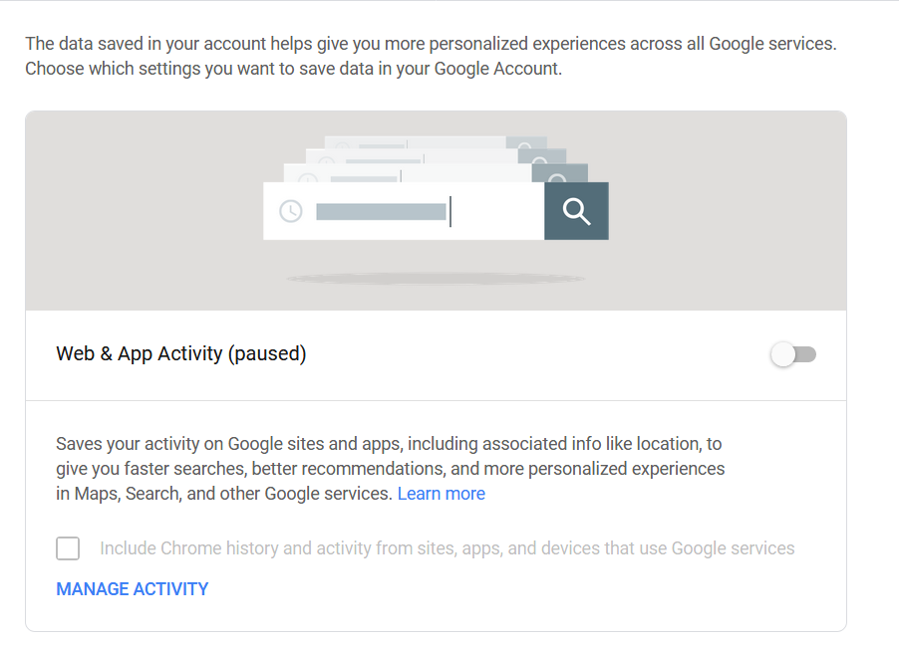
- Also re Google’s data collection you can change your activity controls, Go to your Google Account on the Web, On the left navigation panel, click Data & Personalization. In the Activity controls panel, turn a type of activity on or off. Examples below. This site shows what information Google holds on you. See item 3 to just turn location on or off.

- Beware sharing your location with apps and Google. (Settings > Location > Google Location History)
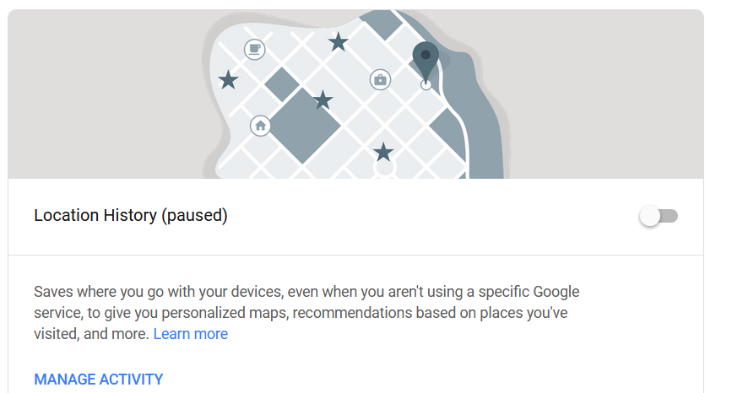
- Lock down your device. Use a code to gain access to your phone or fingerprint if that is available on your phone.

- You can encrypt the data on your phone, I don’t so haven’t tried it.

- Keep the device’s software up-to-date, this is recommended although I don’t do it WARNING, may render your device inoperable. (Settings > About phone/tablet > System Update)

- Be wary of third-party app stores. I mostly use Play Store, you could make a rule that you only use Play Store. Can set in (settings > Security > Unknown sources)

- When installing an app, check its permissions first. Think carefully about whether to continue installation if it’s requesting access to sensitive data. Seek out apps that require the minimum permissions necessary Just check what it wants access to make sure they make sense and correspond to what the app actually does eg. an alarm app does not require a permission to access your text messages.

- Keep Apps updated but always think about it. I have mine set to NOT automatically update, I check which apps need to be updated and then decide. Go to Play Store, from the menu choose ‘My apps and games, and it will list all those requiring an update. You can select which ones you want to update. Some permissions may change, see 7 above, so think about them

- Consider which apps you want syncing with the cloud, personally I don’t sync anything but I’m super careful.

- VPN’s Load a VPN app I use Proxy Master which works well and is free. VPN’s protect you when you are using public WiFi networks which aren’t secure. You can also choose a browser eg Opera which now has built in VPN.

- Use anti-virus software, I use AVG but Avast is supposed to be good.

- Turn off connections when you don't need them. If you're not using Wi-Fi or Bluetooth, turn them off. Besides saving some battery life, network connections can be used to attack you.

- If you lose your phone there are various apps that can locate it, I haven’t used any.

April 2019 Nigel Tennant

